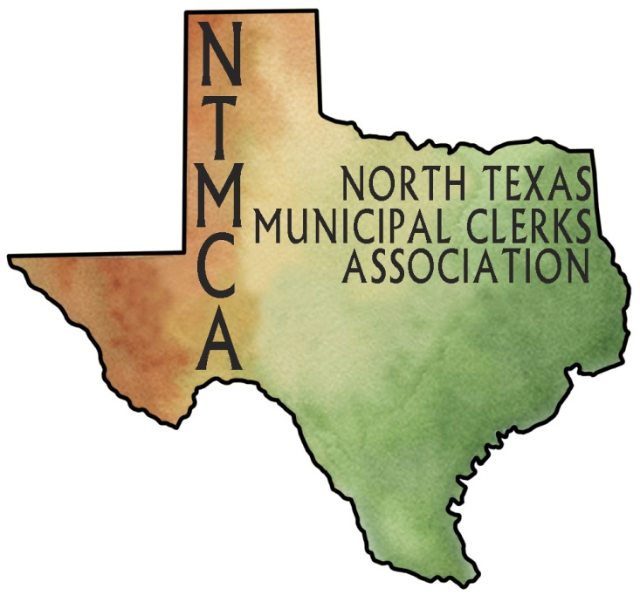
JOIN THE NORTH TEXAS MUNICIPAL CLERKS ASSOCIATION TODAY!

The NORTH TEXAS MUNICIPAL CLERKS ASSOCIATION (NTMCA) is an organization of City Clerks and Secretaries working together to assist and support each other in their positions with municipal government.

NTMCA exists because City Secretaries and Clerks are a viable part of municipal government who want to perform their duties in an effective and economical manner and are dedicated to helping others by sharing experiences, procedures, and solutions to common problems.
NTMCA provides a range of programs and activities to assist City Secretaries and Clerks in achieving their goals of professionalism.
NTMCA produces a monthly newsletter highlighting meetings and informative programs held each month. Position announcements and appointments are also included in the newsletter.
NTMCA sponsors an annual Professional Seminar each year of general interest for all City Secretaries and Clerks.

MEMBERSHIP DUES - $25.00
(For the period of October 1, 2011 through September 30, 2012)

Name: _________________________________________________________________________
Title: _________________________________________________________________________
City: _________________________________________________________________________
Mailing Address: _________________________________________________________________
_______________________________________________________________________________
Phone: ________________________________ Fax: ____________________________________
E-mail:_________________________________________________________________________

Place an [X] in the box(es) if you are:

Texas Registered Municipal Clerk (TRMC) (Graduate of Certification Program)
Enrolled in Texas Registered Municipal Clerks Certification Program
Certified Municipal Clerk (CMC) (Certified by International Institute of Municipal Clerks)
Master Municipal Clerk (MMC)
I wish to make a contribution to the Alyce Deering Scholarship Fund in the amount of $_______

Please make checks payable to NTMCA and mail with this form to:

Diane Cockrell, City Secretary
City of Decatur
P.O. Box 1299
Decatur, Texas 76234

